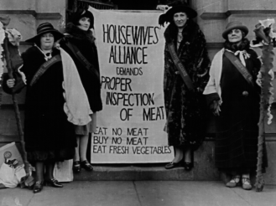
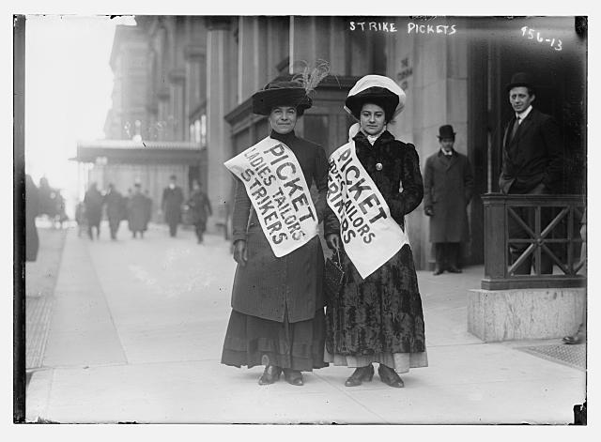
Unit 4 – Progressivism

Essential Question:
- How did movements for political and economic reform take shape in this period, and how effective were they in achieving their goals?

YWBAT:
- Identify the major influences of the Progressive Era and how social movements impacted government and business in America
- Identify how progressive era movements reflected the political, social, and economic realities of America
- Analyze the way literature reveals truths about the human experience
- Identify prominent progressive movement figures

Assessment
- Small group research project/presentation on one particular movement during progressive era
- Open-notes test based on information learned in class from others

Activities
- Research work
- Presenting in front of the class (as group with individual parts)
- Note-taking on others’ presentations
- Teacher directed video clips and short readings

Standards Addressed:
RH.7 - Integrate and evaluate multiple sources of information presented in diverse formats and media (e.g., visually, quantitatively, as well as in words) in order to address a question or solve a problem

RH.9 - Integrate information from diverse sources, both primary and secondary, into a coherent understanding of an idea or event, noting discrepancies among sources.

WH.6 Use technology, including the Internet, to produce, publish, and update individual or shared writing products in response to ongoing feedback, including new arguments or information.

WH.7 Conduct short as well as more sustained research projects to answer a question (including a self-generated question) or solve a problem; narrow or broaden the inquiry when appropriate; synthesize multiple sources on the subject, demonstrating understanding of the subject under investigation.

WH.8 Gather relevant information from multiple authoritative print and digital sources, using advanced searches effectively; assess the strengths and limitations of each source in terms of the specific task, purpose, and audience; integrate information into the text selectively to maintain the flow of ideas, avoiding plagiarism and overreliance on any one source and following a standard format for citation.

HS.5. Examine and evaluate the origins of fundamental political debates and how conflict, compromise, and cooperation have shaped national unity and diversity in world, U.S., and Oregon history.

HS.6. Analyze ideas critical to the understanding of history, including, but not limited to: populism, progressivism, isolationism, imperialism, communism, environmentalism, liberalism, fundamentalism, racism, ageism, classism, conservatism, cultural diversity, feminism, and sustainability.

